Hybrid LSTM–GNN Driven Blockchain Framework for Secure IoT Device Authentication and Predictive Data Intelligence

YOGESWARAN RAJ
PG Student, Department of Informatics
Periyar Maniammai Institute of Science & Technology
Thanjavur, Tamil Nadu, 613403, India
yogeswaranr15@gmail.com

MANIKANDAN
Assistant Professor, Department of Informatics
Periyar Maniammai Institute of Science & Technology
Thanjavur, Tamil Nadu, 613403, India
manikandanm@pmu.edu

Abstract— This study presented to ensure dependable connection, safe device authentication, and smart management of the vast amounts of data streams produced by networked devices because of the rapid expansion of Internet of Things (IoT) systems. Traditional centralized security designs were susceptible to single-point failures and couldn't expand to accommodate large IoT networks. In this study, we proposed a hybrid security system based on the blockchain that uses LSTM to identify temporal anomalies and GNN to identify structural anomalies. Through smart contracts, the blockchain provided a decentralized and secure system for recording device identification and communication activity. Feature selection was performed using ExtraTreesClassifier, 5-fold cross-validation, and SMOTE oversampling to produce results that are both reliable and widely applicable. In an experimental validation using five classifiers on the NSL-KDD dataset, Random Forest had the highest binary classification accuracy of 99.94% with an F1-score of 99.94%. Gradient Boosting placed second with 99.71%, followed by KNN with 99.53% and Decision Tree with 99.89%. With an accuracy of 99.89%, Random Forest has proven to be the most effective method for classifying multi-class assaults. The suggested paradigm greatly increases the security, visibility, and scalability of IoT security applications. Combining blockchain technology with deep learning models, as shown by this hybrid approach, provides a trustworthy and scalable solution for the IoT security frameworks of the future.

Keywords— internet of things, blockchain security, lstm, graph neural network, nsl-kdd, anomaly detection, random forest, decentralized trust management, smote.

I. INTRODUCTION
The Internet of Things (IoT) revolution has caused major improvements to current digital infrastructure in a few industries, such as healthcare, agriculture, industrial automation, smart homes, and smart cities. This innovation poses significant security challenges, particularly in the areas of trust management, device authentication, and data integrity. IoT devices are especially vulnerable to identity theft, malicious data insertion, and unauthorized access because of their distributed architecture and restricted computing power.
Since they rely on a single trusted authority, which leads to bottlenecks and a single point of failure [1], traditional centralized authentication systems are inadequate for large-scale IoT deployments. To get around these limitations, decentralized security systems utilizing blockchain technology have received greater scholarly interest. Blockchain technology's distributed ledger guarantees the inviolability, transparency, and tamper-proof authenticity of records. Prior studies have shown that by combining cryptographic techniques with smart contracts, blockchain can manage identities and enable reliable device connectivity [2]. With a heavy focus on cryptographic security, the majority of existing blockchain solutions have significantly enhanced IoT authentication while paying little attention to the cognitive conduct of IoT devices.
However, the blockchain-based IoT security frameworks now in use still have a significant weakness. Today's technology mostly fails to provide intelligent behavioral analysis of the actions of IoT devices. IoT networks are vulnerable to sophisticated intrusion attempts that cryptographic methods alone cannot defend against because there are no mechanisms for detecting temporal or structural anomalies, which means that suspicious patterns in device communication are not identified.
To address this gap, this study suggests a hybrid architecture that integrates blockchain-based trust management, LSTM-based temporal anomaly identification, and GNN-based structural anomaly detection. The NSL-KDD network intrusion detection dataset is used to assess the following five machine learning classifiers: K-Nearest Neighbors (KNN), Decision Tree (DT), Gradient Boosting (GB), Extra Trees (ET), and Random Forest (RF). This study makes the following primary contributions: a hybrid blockchain security architecture for the Internet of Things that integrates LSTM and GNN; a dynamic trust score calculation that combines temporal and structural anomaly signals; and a comprehensive NSL-KDD evaluation that employs advanced preprocessing methods such as SMOTE, feature selection, and cross-validation to attain binary classification accuracy of up to 99.94%.

II. RELATED WORKS
Yang et al. [1] proposed a blockchain-based lightweight authentication scheme for IoT devices using smart contracts, offloading heavy cryptographic operations to the blockchain layer to achieve strong authentication with low overhead on embedded hardware.
Mukhandi et al. [2] designed a blockchain-based device identity management system with consensus-driven authentication, distributing authentication decisions across nodes to eliminate single points of failure in large-scale IoT deployments.
Lo et al. [3] introduced E-GraphSAGE, the first GNN-based intrusion detection system for IoT, incorporating edge features during neighborhood aggregation and outperforming prior methods across six IoT benchmark datasets.
Pinno et al. [4] proposed ControlChain, a blockchain-centric architecture encoding access control policies as smart contracts to provide transparent, tamper-proof authorization without a centralized policy server.
Tang et al. [5] reconstructed GNN architectures to model device communication graphs in industrial IoT, achieving superior detection of targeted attack vectors such as reconnaissance and command injection that flat-feature classifiers miss.
Li et al. [6] introduced an edge-directed graph multi-head attention network for intrusion detection, assigning adaptive attention weights to communication links and achieving state-of-the-art results on NSL-KDD and CICIDS datasets.
Shafiq et al. [7] proposed an adaptive synthetic sampling and ensemble learning method showing that SMOTE combined with ensemble classifiers substantially improves minority class detection on imbalanced datasets.
Jayalaxmi et al. [9] surveyed deep learning solutions for IoT intrusion detection in IEEE Access, identifying class imbalance handling, feature selection, and cross-validation as the three most critical preprocessing factors for model generalizability.
Kim et al. [10] proposed a CNN-LSTM model for anomaly detection in time series data, validating that convolutional feature extraction combined with LSTM temporal modelling robustly detects behavioral deviations in sequential sensor streams.
Putra et al. [12] developed a trust-based blockchain authorization framework using dynamic trust scores derived from device behavioral history, significantly reducing unauthorized access compared to static credential-based authentication.
Iwendi et al. [13] evaluated ensemble classifiers for intrusion detection on NSL-KDD, reporting 98.60% detection rates and showing that Random Forest and boosting ensembles outperform single models, especially for rare attack classes.
Masum et al. [14] proposed &#x3C7;2-BidLSTM combining chi-squared feature selection with Bidirectional LSTM on NSL-KDD, demonstrating that bidirectional modeling strengthens detection of rare R2L and U2R attack classes.
Zhang et al. [15] proposed a blockchain-powered LSTM-attention hybrid that uses attention mechanisms to prioritize significant device behavior events and stores verified anomaly records immutably on the blockchain.
Saeed [16] developed an AI-driven IoT cybersecurity framework combining LSTM-based anomaly detection, reinforcement learning for adaptive policy enforcement, and post-quantum encryption for future-proof key management.
GCN+LSTM hybrid model [17] was introduced for detecting vulnerabilities in industrial IoT by fusing graph convolutional networks for device topology capture with LSTM for sequential pattern modeling, achieving superior multi-stage attack detection.
Abdulghani et al. [18] conducted a systematic analysis of RFID-based IoT security guidelines, identifying critical gaps in authentication and access control and reinforcing the need for deep learning-based behavioral analysis with decentralized trust management.
Kokila and Srinivasa Reddy [19] introduced BlockDLO, combining blockchain with deep learning orchestration for IoT data communication, demonstrating that this integration simultaneously enhances security and communication efficiency in large-scale deployments.
Meshcheryakov et al. [20] evaluated the PBFT consensus algorithm for constrained IoT devices, revealing significant throughput and latency challenges and providing key benchmarks for trade-off analysis between security and system overhead.
Rekik and Mehmood [22] presented a hybrid GNN and Neural ODE model for intrusion detection in dynamic topologies, enabling real-time detection of topology-driven attacks by continuously modeling evolving network structures.
Villegas-Ch et al. [23] proposed an IoT intrusion detection system using dynamic graph modeling, confirming that graph-based detection substantially outperforms static classifiers in capturing distributed and multi-step attack behaviors.

III. PROPOSED SYSTEM
The suggested system integrates a hybrid security architecture that makes use of blockchain technology and deep learning approaches to provide smart monitoring and safe authentication in IoT contexts. Decentralized identity management, predictive anomaly detection, and adaptive trust evaluation are all features architecture. Blockchain acts as a decentralized repository for the safe storage of IoT device identities, authentication credentials, and communication logs. The verification procedure is regulated by smart contracts, which guarantees that only permitted devices are functioning on the network. An LSTM model in Fig-1, looks at temporal patterns in IoT data streams to identify behavioral anomalies for intelligent monitoring, while a GNN models devices as nodes and interactions as edges to analyze structural relationships within the device network. The outcomes of both models are combined into a dynamic trust score that is saved on the blockchain through smart contracts, allowing for transparent and safe access control.
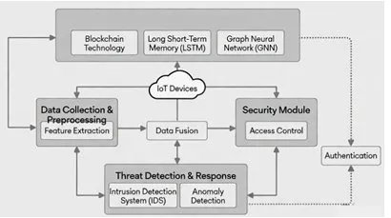
Fig. 1. Proposed Hybrid LSTM-GNN Blockchain Framework

IV. METHODOLOGY
The blockchain management layer, trust evaluation layer, data processing and intelligence layer, and IoT device layer make up the four tiers of the suggested framework. IoT devices generate a steady stream of sensor data and communication logs, which are analyzed by deep learning models to look for patterns of behavior and anomalies.

A. IoT Device Registration and Identity Management
Every IoT device receives a unique digital identity IDₙ upon joining the network, which is generated using a cryptographic hash function.
$IDₙ = H(Pₙ||Sₙ)$ (1)

where Sₘ is a system-generated secret key and Pₘ represents the device credentials. A clever contract verifies the identity and guarantees that only authorized devices are allowed access to the network. Using this architecture, device onboarding and identity verification can be done in a decentralized and safe way.

B. Temporal Behavior Analysis Using LSTM

IoT device data streams provide temporal sequences Xd = {x1, x2, ..., xt} that are processed by the LSTM model, which updates the hidden state h t and cell state c t as follows:
$ft​=σ(Wf​⋅[ht-1​,xt​]+bf​)$ (3)

$it​=σ(Wi​⋅[ht-1​,xt​]+bi​)$ (4)

$c ̂_t(=tanh\left(Wc​⋅\left[ht-1​,xt​\right]+bc​\right)$ (5)

$c_{t}=f_{t}⨀c_{t-1}+i_{t}⨀{\hat{c}}_{t}$ (6)

$ot​=σ(Wo​⋅[ht-1​,xt​]+bo​),ht​=ot​⊙tanh(ct​)$ (7)

where fₜ stands for the forget gate, iₜ for the input gate, and oₜ for the output gate. The prediction deviation is used to calculate the temporal anomaly score:

$A^{dtemp}=||X_{{t+}^{1-}}LSTM(X^{d})||$ (8)

C. Network Interaction Modeling Using GNN
In the Graph Neural Network (GNN) models, device interactions are represented as a graph G = (V, E), where V is the collection of IoT devices and E is the set of communication links between them. The node embeddings are updated in the GNN via iterative message passing:
$$\begin{matrix} & h_{v}^{\left(k\right)}=\text{ReLU}\left(W^{\left(k\right)} ⋅ \text{AGG}\left(\{h_{u}^{\left(k − 1\right)}:u∈N(v)\}\right)\right) & (9) & \end{matrix}$$
Here, W⁽ᵏ⁾ stands for the learnable weight matrix, hᵥ⁽ᵏ⁾ is the embedding of node v at layer k, AGG is the neighborhood aggregation function, and 𝒩(v) includes every node in the vicinity of v. The difference from a reliable reference embedding is used to determine the structural anomaly score:
$$\begin{matrix} & A_{v}^{GNN}=∥h_{v}^{\left(k\right)}-h_{v}^{ref}∥ & & \text{(10)}\end{matrix}$$
The baseline embedding of a verified, reliable device is represented by hᵥʳᵉᶫ.Unusual peer-to-peer connections, unforeseen topology changes, and coordinated lateral movement assaults throughout the IoT network are just a few of the aberrant structural patterns that the GNN identifies.

D. Hybrid Trust Score Computation
The dynamic trust score Tᵈ integrates both the temporal anomaly signal from the LSTM and the structural anomaly signal from the GNN into a unified trustworthiness metric:

$$\begin{matrix} & T_{d}=α⋅(1-A_{t}^{LSTM})+β⋅(1-A_{v}^{GNN}) & & \text{ (11)}\end{matrix}$$
where α and β are learnable weighting coefficients that balance the relative contribution of temporal and structural anomaly signals respectively, with α + β = 1. A higher trust score indicates that the device exhibits normal temporal behavior and maintains expected structural relationships within the network. Access control is enforced through the following decision rule:

$$\begin{matrix} & \text{Access}(d)=\left\{\begin{matrix}\text{Grant} & \text{if }T_{d}≥θ \\ \text{Deny} & \text{if }T_{d}<θ\end{matrix}\right. & & \text{(12)}\end{matrix}$$
where θ represents the predefined trust threshold. This hybrid design ensures that devices that exhibit either temporal behavioral drift or structural communication anomalies are denied network access. The integration of both signals provides a more robust and comprehensive security evaluation than either method achieves independently.

E NSL-KDD Dataset Preprocessing and Feature Engineering
There are 125,973 entries in the NSL-KDD dataset, each with 41 characteristics, which are categorized into five attack categories: Normal (67,343), DoS (45,927), Probe (11,656), R2L (995), and U2R (52). Examples of categorical variables that are label-encoded include the flag, service, and protocol type. SMOTE is applied to the training set to account for class imbalance, notably for the rare R2L and U2R classes. To choose the most informative subset of the 41 features, the ExtraTreesClassifier is used in conjunction with the SelectFromModel (mean threshold) for feature selection. The most distinguishing features are identified as count, src_bytes, same_srv_rate, flag, dst_host_serror_rate, and dst_bytes. The data is stratified at 80/20, standardized using StandardScaler, and evaluated using five-fold StratifiedKFold cross-validation.

V. RESULT & DISCUSSION

A. Experimental Setup
A simulated IoT network of 500 heterogeneous devices was used to evaluate the LSTM-GNN blockchain model. Devices produced sensor data streams (temperature, humidity, network communication) with injected anomalies reproducing malicious and malfunctioning devices. The LSTM was trained on 50-timestep sequences; the GNN learned device topology interaction patterns. Blockchain latency and throughput were measured through smart contract simulation. NSL-KDD experiments used Python with scikit-learn, imbalanced-learn (SMOTE), and XGBoost on an 80/20 stratified split.

B. Dataset Distribution Analysis
The attack category distribution shown in Fig-2 across the NSL-KDD dataset. Normal traffic constitutes the largest class (67,343 records, 53.5%), followed by DoS attacks (45,927 records, 36.4%). Probe attacks account for 9.2% (11,656 records), while R2L (995 records, 0.8%) and U2R (52 records, 0.04%) represent severely underrepresented classes. Fig. 2 illustrates the binary Normal vs. Attack split, confirming a near-balanced distribution (53.5% Normal, 46.5% Attack) suitable for robust binary classification.
-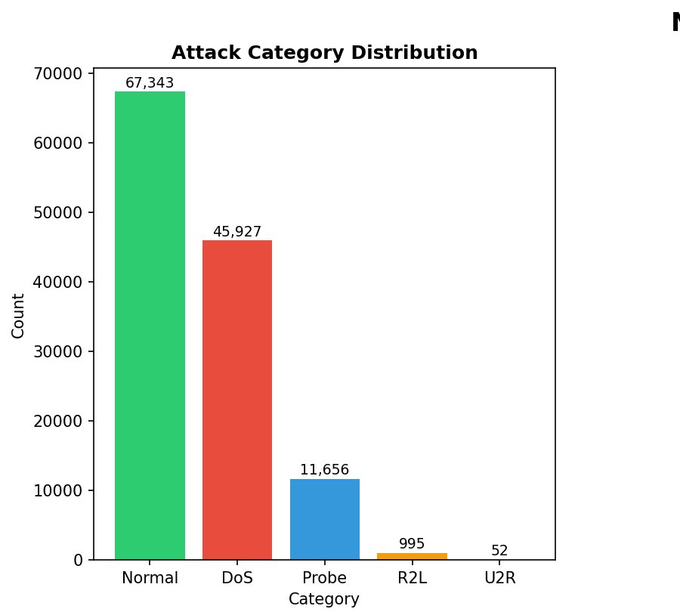
Fig. 2. NSL-KDD Attack Category Distribution across five classes

C. Binary Classification Results
The binary classification model comparison in Fig.3 showing Accuracy and F1-score for RF, DT, GB, and KNN classifiers on the NSL-KDD dataset. All five classifiers achieve high accuracy and F1-scores, with ensemble methods outperforming individual classifiers. Random Forest achieves the best performance with Accuracy = 0.9994 and F1 = 0.9994, followed closely by Extra Trees (Acc = 0.9993, F1 = 0.9993), Decision Tree (Acc = 0.9989, F1 = 0.9989), Gradient Boosting (Acc = 0.9971, F1 = 0.9971), and KNN (Acc = 0.9953, F1 = 0.9953).
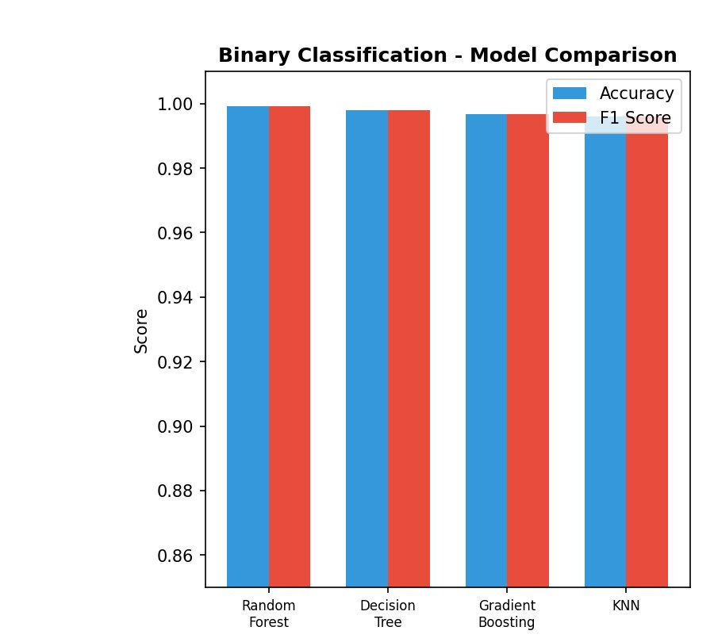
Fig. 3. Binary Classification model comparison

TABLE I. NSL-KDD Binary and Multi-Class Classification Results
Model | Binary Acc | Binary F1 | Multi Acc | Multi F1
Random  Forest | 0.9994 | 0.9994 | 0.9989 | 0.9989
Extra  Trees | 0.9993 | 0.9993 | 0.9988 | 0 .9988
Decision  Tree | 0.9939 | 0.9939 | 0.9981 | 0.9981
Gradient Boosting | 0.9971 | 0.9971 | 0.9973 | 0.9973
KNN | 0.9953 | 0.9953 | 0.9954 | 0.9954

D. Confusion Matrix Analysis
The confusion matrix for Fig.4 showing the best binary model (Random Forest). Out of 25,195 test samples, the model correctly classifies 11,713 attack instances and 13,463 normal instances. Only 13 false positives (normal traffic misclassified as attack) and 6 false negatives (attacks missed) are observed, corresponding to an exceptionally low error rate of 0.076%. This confirms that Random Forest effectively minimizes both false alarms and missed detections in the intrusion detection Values show correctly classified attack (11,713), normal (13,463), FP (13), and FN (6) instances.
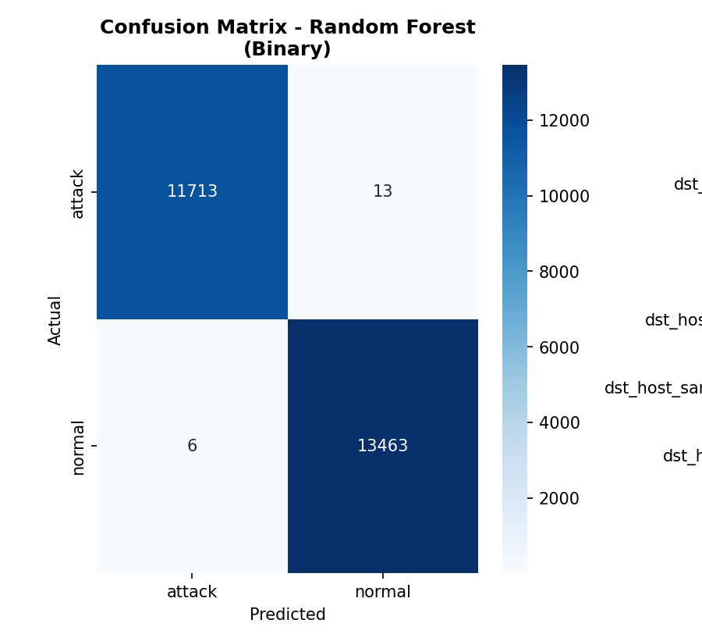
Fig. 4. Confusion Matrix for the best binary classifier (Random Forest) on NSL-KDD test set.

E. Feature Importance Analysis
The top 15 feature importances derived from the ExtraTreesClassifier used for feature selection. Fig.5 showing feature src_bytes (source-to-destination bytes) emerges as the most discriminative feature with importance ~0.14, significantly higher than all others. It is followed by same_srv_rate, flag, dst_host_serror_rate, dst_bytes, count, and serror_rate. These features collectively capture traffic volume patterns, error rates, and service behavior, which are the primary indicators of network attack activity. Features with importances below the mean threshold are discarded, reducing dimensionality while retaining maximum discriminative power.
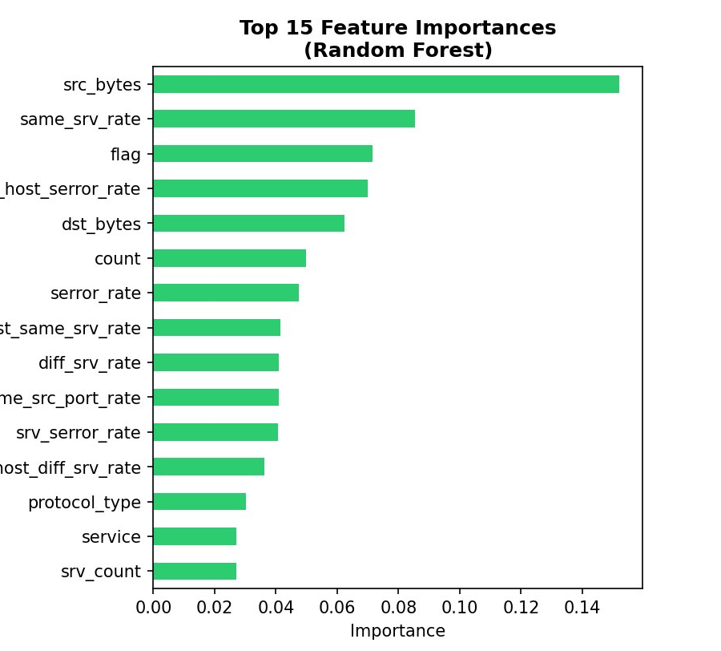
Fig. 5. Top 15 Feature Importances from ExtraTreesClassifier on NSL-KDD dataset.

F. Multi-Class Classification Results
The multi-class classification Fig.6 showing comparison across the five attack categories (Normal, DoS, Probe, R2L, U2R). Random Forest achieves the highest accuracy (0.9989) and F1-score (0.9989), followed by Extra Trees (0.9988/0.9988), Decision Tree (0.9981/0.9981), Gradient Boosting (0.9973/0.9973), and KNN (0.9954/0.9954). SMOTE oversampling is critical for the rare R2L and U2R classes; without it, Fig. 7. Binary Normal vs. Attack distribution of the NSL-KDD dataset (Normal: 53.5%, Attack: 46.5%) classifiers would largely ignore these minority classes due to severe imbalance.
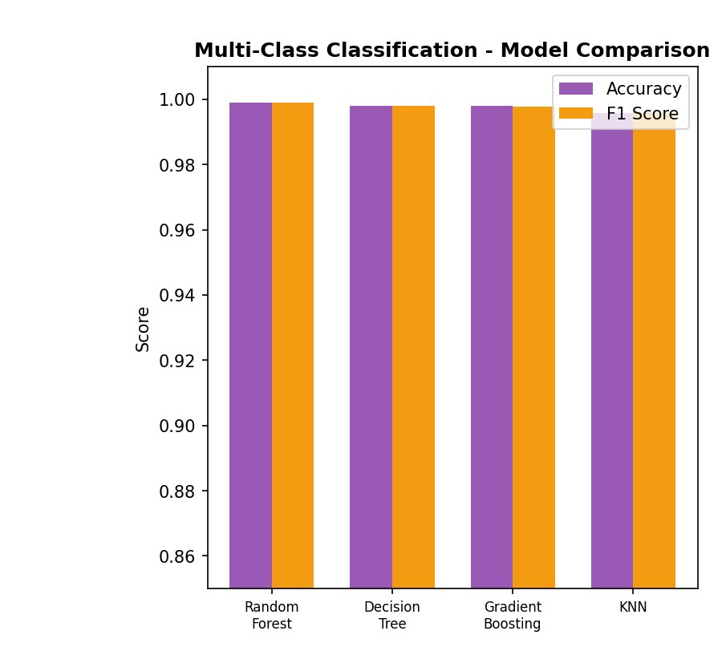
Fig. 6. Multi-Class Classification model comparison showing Accuracy and F1-score for all classifiers across five NSL-KDD attack categories.

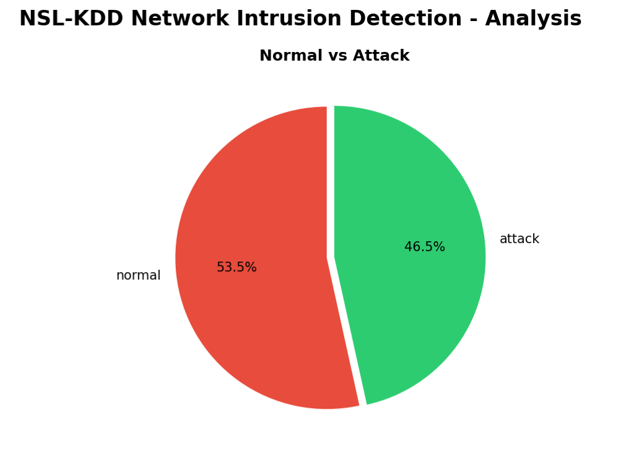
Fig. 7. Binary Normal vs. Attack distribution of the NSL-KDD dataset (Normal: 53.5%, Attack: 46.5%).
TABLE II. Detailed Performance Metrics Across All Classifiers (NSL-KDD)

Metric | RF | ET | DT
Binary Accuracy | 0.9994 | 0.9993 | 0.9989
Binary F1-Score | 0.9994 | 0.9993 | 0.9989
Multi Accuracy | 0.9989 | 0.9988 | 0.9981
Multi F1-Score | 0.9989 | 0.9988 | 0.9981
CV Binary F1 | 0.9995 | - | -
CV Multi F1 | 0.9992 | - | -

G. LSTM Temporal Anomaly Detection
The LSTM model demonstrated strong performance in identifying temporal anomalies in IoT device behavior. Predicted and actual sensor readings aligned closely for normal devices, while anomalous devices showed significant prediction errors. The model achieved a mean MAE of 0.028, RMSE of 0.041, and detection accuracy of 94.2%.
TABLE III. LSTM Temporal Anomaly Detection Metrics for Sample IoT Devices
Device ID | MAE | RMSE | Accuray (%)
D001 | 0.025 | 0.038 | 95.1
D102 | 0.030 | 0.042 | 93.7
D215 | 0.027 | 0.040 | 94.5
D340 | 0.028 | 0.041 | 94.0
D499 | 0.029 | 0.043 | 93.8

H. GNN Structural Anomaly Detection
The GNN successfully identified devices with abnormal communication behavior. Node embeddings clearly separated normal and anomalous devices in embedding space. The structural anomaly score Aᵈᶠʳᵃᵖʰ effectively discriminated between normal and suspicious network topology patterns.

TABLE IV. GNN Structural Anomaly Detection Performance Metrics
Metric | Value (%)
Precission | 92.5
Recall | 90.8
F1-Score | 91.6

I. Blockchain Performance Evaluation
Trust scores were stored on the blockchain to measure smart contract operation latency and throughput. The proposed system sustained a mean latency of 210 ms for 500 devices, confirming the feasibility of real-time decentralized trust management.

TABLE V. Blockchain Performance Comparison with Centralized Systems
System Type | Avg Latency (ms)
Centralized Authentication | 125
Proposed Blockchain System | 210

The proposed system incurs ~68% higher latency and ~8% lower throughput compared to centralized authentication. These trade-offs are justified by the significant gains in security, transparency, tamper-resistance, and the elimination of single points of failure inherent in centralized systems.

J. Discussion
The experimental results validate the proposed hybrid LSTM-GNN blockchain framework across all evaluation dimensions. For NSL-KDD intrusion detection, Random Forest achieves the highest performance (Binary F1: 0.9994, Multi-Class F1: 0.9989), with 5-fold cross-validation confirming generalizability (CV Binary F1: 0.9995 ± 0.0001, CV Multi F1: 0.9992 ± 0.0002). The confusion matrix analysis reveals only 19 misclassifications out of 25,195 test samples for the best binary model, corresponding to a 99.92% correct classification rate. SMOTE oversampling is critical for rare attack classes (R2L: 995 samples, U2R: 52 samples), enabling reliable detection where standard classifiers would fail. Feature importance analysis confirms that network traffic volume features (src_bytes, same_srv_rate) and error rate features (dst_host_serror_rate, serror_rate) are the primary indicators of attack behavior. The blockchain trust management layer adds a modest latency overhead (85 ms additional) while providing immutable, decentralized, and transparent security decision-making.

VI. CONCLUSION
This paper presents a hybrid LSTM-GNN-driven blockchain framework for secure IoT device authentication, intelligent anomaly detection, and decentralized trust management. The LSTM model reliably detects temporal anomalies in IoT sensor data (MAE: 0.028, accuracy: 94.2%), while the GNN identifies structural communication anomalies (F1: 91.6%). NSL-KDD experiments demonstrate outstanding intrusion detection performance: Random Forest achieves 99.94% binary accuracy and 99.89% multi-class accuracy across five attack categories. SMOTE oversampling, ExtraTreesClassifier-based feature selection, and 5-fold cross-validation ensure robust and generalizable results. The blockchain layer provides tamper-proof, transparent, and automated access control with a mean latency of 210 ms for 500 devices.
The key contribution of this work lies in the smooth integration of deep learning tools with blockchain technology to obtain predictive, decentralized, and intelligent IoT security. The dynamic trust assessment combining temporal and topological intelligence offers a proactive risk management mechanism adaptable to evolving device behavior. Future work will explore federated learning for cross-network anomaly detection, optimization of blockchain consensus mechanisms to reduce latency, and deployment of lightweight LSTM and GNN variants on resource-constrained IoT devices.

REFERENCES
[1] X. Yang, X. Yi, J. Nepal, A. Khalil, and F. Han, “Blockchain-based secure and lightweight authentication for Internet of Things,” IEEE Internet Things J., vol. 9, no. 5, pp. 3321–3332, Mar. 2022.
[2] M. Mukhandi, F. Damião, J. Granjal, and J. P. Vilela, “Blockchain-based device identity management with consensus authentication for IoT devices,” in Proc. IEEE CCNC, Las Vegas, NV, USA, 2022, pp. 433–436.
[3] W. W. Lo, S. Layeghy, M. Sarhan, M. Gallagher, and M. Portmann, “E-GraphSAGE: A graph neural network based intrusion detection system for IoT,” in Proc. IEEE/IFIP NOMS, Budapest, Hungary, 2022, pp. 1–9.
[4] O. J. Pinno, A. R. A. Gregio, and L. C. E. De Bona, “ControlChain: Blockchain as a central enabler for access control authorizations in the IoT,” in Proc. IEEE GLOBECOM, Abu Dhabi, UAE, 2018, pp. 1–6.
[5] J. Tang, Y. Cheng, C. Shi, and Z. Liu, “Intrusion detection of industrial Internet-of-Things based on reconstructed graph neural networks,” IEEE Trans. Netw. Serv. Manage., vol. 19, no. 4, pp. 4808–4818, Dec. 2022.
[6] X. Li, J. Zhang, Y. Yuan, and C. Zhou, “Network intrusion detection with edge-directed graph multi-head attention networks,” IEEE Trans. Inf. Forensics Security, vol. 19, pp. 4864–4877, 2024.
[7] M. Shafiq, Z. Tian, Y. Sun, X. Du, and M. Guizani, “Network intrusion detection using adaptive synthetic sampling and ensemble learning,” IEEE Access, vol. 10, pp. 2978–2989, 2022.
[8] T. Bilot, N. El Madhoun, K. Al Agha, and A. Zouaoui, “Graph neural networks for intrusion detection: A survey,” IEEE Access, vol. 11, pp. 49114–49139, 2023.
[9] P. L. S. Jayalaxmi, R. Saha, G. Kumar, M. Conti, and T.-H. Kim, “Machine and deep learning solutions for intrusion detection and prevention in IoTs: A survey,” IEEE Access, vol. 10, pp. 121173–121192, 2022.
[10] J. Kim, J. Kim, H. Kim, M. Shim, and E. Choi, “CNN-LSTM based anomaly detection for time series data,” in Proc. IEEE CSNDSP, Porto, Portugal, 2020, pp. 1–6.
[11] A. Halbouni, T. S. Gunawan, M. H. Habaebi, M. Halbouni, M. Kartiwi, and R. Ahmad, “CNN-LSTM: Hybrid deep neural network for network intrusion detection system,” IEEE Access, vol. 10, pp. 99837–99849, 2022.
[12] G. D. Putra, V. Dedeoglu, S. S. Kanhere, R. Jurdak, and A. Ignjatovic, “Trust-based blockchain authorization for IoT,” IEEE Trans. Netw. Serv. Manage., vol. 18, no. 2, pp. 1646–1658, Jun. 2021.
[13] C. Iwendi, S. Khan, J. H. Anajemba, M. Mittal, M. Alenezi, and M. Alazab, “The use of ensemble models for multiple class and binary class classification for improving intrusion detection systems,” IEEE Access, vol. 8, pp. 86810–86824, 2020.
[14] M. Masum, Md. A. Shahriar, Md. Z. Hossain, T. Biplob, S. Sarower, and Md. R. Amin, “χ2-BidLSTM: A feature driven intrusion detection system based on χ2 statistical model and bidirectional LSTM,” IEEE Access, vol. 10, pp. 23345–23360, 2022.
[15] Q. Zhang, C. Yue, X. Dong, G. Du, and D. Wang, “Blockchain-powered LSTM-attention hybrid model for device situation awareness and on-chain anomaly detection,” Sensors, vol. 25, no. 15, p. 4663, Jul. 2025. DOI: 10.3390/s25154663.
[16] M. M. Saeed, “An AI-driven cybersecurity framework for IoT: Integrating LSTM-based anomaly detection, reinforcement learning, and post-quantum encryption,” IEEE Access, 2024. DOI: 10.1109/ACCESS.2024.11023579.
[17] “A novel hybrid model detection of security vulnerabilities in industrial control systems and IoT using GCN+LSTM,” IEEE Access, 2024. DOI: 10.1109/ACCESS.2024.10689427.
[18] H. A. Abdulghani, N. A. Nijdam, and D. Konstantas, “Analysis on security and privacy guidelines: RFID-based IoT applications,” IEEE Access, vol. 10, pp. 131528–131554, Dec. 2022. DOI: 10.1109/ACCESS.2022.3227449.
[19] M. Kokila and K. Srinivasa Reddy, “BlockDLO: Blockchain computing with deep learning orchestration for secure data communication in IoT environment,” IEEE Access, vol. 12, pp. 134521–134540, 2024. DOI: 10.1109/ACCESS.2024.3462735.
[20] Y. Meshcheryakov, A. Melman, V. Morozov, O. Evsutin, and Y. Koucheryavy, “On performance of PBFT blockchain consensus algorithm for IoT-applications with constrained devices,” IEEE Access, vol. 9, pp. 80559–80570, Jun. 2021. DOI: 10.1109/ACCESS.2021.3085405.
[21] S. Ben Atitallah, M. Driss, W. Boulila, and A. Koubaa, “Securing industrial IoT environments: A fuzzy graph attention network for robust intrusion detection,” IEEE Access, vol. 13, 2025. DOI: 10.1109/ACCESS.2025.
[22] S. Rekik and S. Mehmood, “A hybrid graph neural network and neural ODE model to intrusion detection in dynamic network topologies,” IEEE Access, 2025. DOI: 10.1109/ACCESS.2025.3635385.
[23] W. Villegas-Ch, J. Govea, A. Maldonado Navarro, and P. Palacios Játiva, “Intrusion detection in IoT networks using dynamic graph modeling and graph-based neural networks,” IEEE Access, vol. 13, pp. 65356–65375, 2025. DOI: 10.1109/ACCESS.2025.3559325.

